Volunteer Mowers!
Want some LEAF RELIEF this fall?
We’ve got great news: I WANT TO MOW YOUR LAWN received a grant from Home Depot’s Community Impact Grant program, and we have 20 “Leaf-Relief: Yard Vacs for Volunteers” kits to give away.
Each Leaf-Relief kit includes a pack of Home Depot 30-gallon paper lawn/leaf bags, premium cowhide leather gloves, and a RYOBI 40V Vac-Attack Cordless Leaf Vacuum/Mulcher with 5.0 Ah battery and charger.
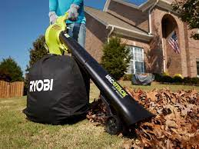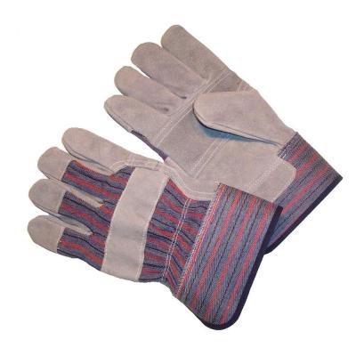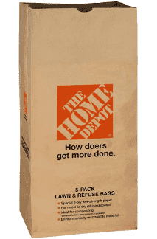
To be eligible for a new leaf vacuum (and leaf bags and heavy-duty yard gloves), you must:
- Mow 10 lawns by August 15, 2022 (which also puts you into our A-Cut-Above Club!)
- Tell us that you want to be in the drawing for the Leaf-Relief Kit, provided with support from Home Depot’s Community Impact Grant.
- Agree to the social media requirements – basically agree to snap a picture of you and your Leaf-Relief Kit with the yard owner and post to your social media account or email/text to us.
For details, visit our Leaf-Relief page on the website here or email us at volunteer@IWantToMowYourLawn.com.
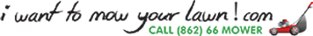
Special thanks to Home Depot Foundation!
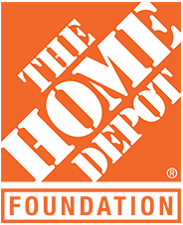
We are so grateful to be a recipient of a Home Depot Community Impact Grant!

